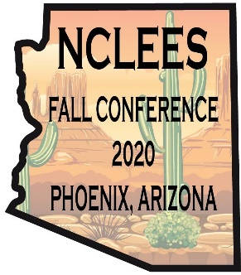
The Arizona Law Enforcement Emerald Society
NCLEES 2020 Fall Conference
Sponsorship Levels
*Limited availability*
November 5-8, 2020 at The Scottsdale Resort at McCormick Ranch

Level 1: $400 Logo on Website, Projector at Resort & Poster in Meeting Room
Level 2: $500– Includes lower levels & Logo on all Conference material
Level 3: $1000 – Includes lower levels & two meals at opening Celebration, Nov. 5 OR Dinner, Nov. 6
Level 4: $1500 –Includes lower levels, & recognition as Meeting Sponsor
Level 5: $2500 –Includes lower levels & recognition as Hospitality Sponsor

Visit https://azemeraldsociety.org/store?olsPage=t%2Fnclees-conf-2020-az
or contact us at azemeraldsociety@gmail.com

ALEES is a 501©3 Organization, Tax Id: 82-4191100
Supporting our law enforcement personnel & their families

