***Current Uniform status***

Updated: 3/15/2018

NOTE: Click on the pictures to take you to the website and a closer look at each item

***Badge:*** Oregon Police Emerald Society Badge.

Order from Terry O’Keeffe. Cost is $130.00 plus S&H.

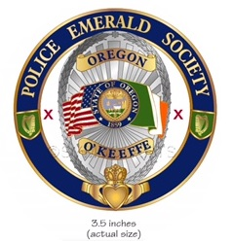

***Patch:*** Oregon Police Emerald Society Patch.

Order from Terry O’Keeffe. Cost is $5.00 plus S&H.

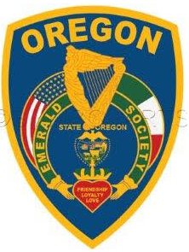

***Uniform Shirt:*** LawPro 100% Polyester Uniform Shirt – ***Black***.

**Short Sleeve - *Black* Long Sleeve - *Black***

$17.99 $18.99

LawPro Short Sleeve Uniform Shirt LawPro Long Sleeve Uniform Shirt

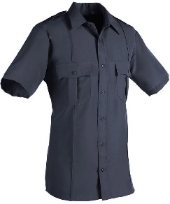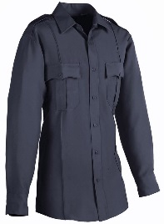

Click picture to buy/visit site (use vendor of your choosing) Click picture to buy/visit site

***Kilt:*** Members may choose from two versions of the “Black Watch Ancient” Tartan.

Ordered from: "The Celtic Croft" http://www.kilts-n-stuff.com

**Option #1**

$299

Poly Viscose Casual Kilt

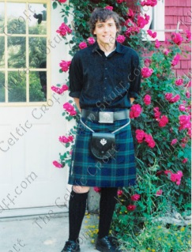

Click picture to buy/visit site

***Sporran:*** “Oregon Police Emerald Society” – Black leather fur body with silver tassels and blue,

leather tips (Keeping with the “thin blue line” theme). Will include silver badge on flap.

$190

***Contact: Tammy Jennex***

***L&M Highland Outfitters***

[***sales@landmhighland.com***](mailto:sales@landmhighland.com)

***Phone: 902-405-7401***

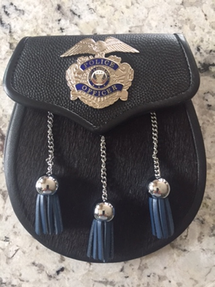

<https://www.landmhighland.ca/contact/>

***Belt:*** Members may choose from two versions.

**Option #1 Option #2**

$49 $25

Quality Embossed Leather Kilt Belt Economy Pebble Grain Leather Kilt Belt

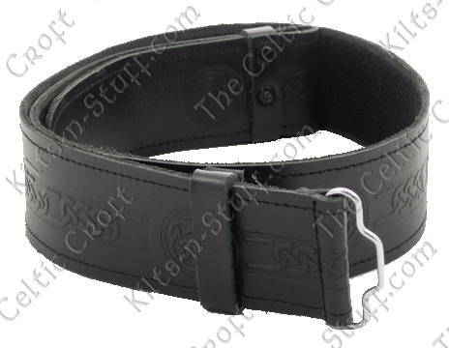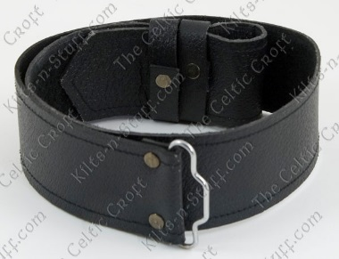

Click picture to buy/visit site Click picture to buy/visit site

***Buckle:*** Rectangular “Celtic Cross Antiqued” with limited options:

***-Members may add their military service insignia or clan crest***

***-Color must be chrome, pewter or silver (not gold, brass or otherwise conflict with***

***badge)***

**Example #1 Example #2**

$25 $25

Antiqued Celtic Cross Kilt Belt Buckle Celtic Cross Antiqued Kilt Belt Buckle

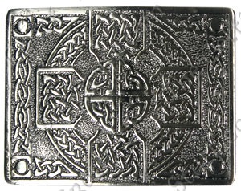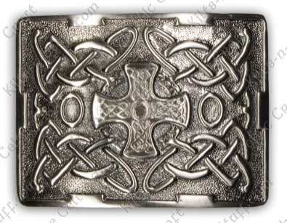

Click picture to buy/visit site Click picture to buy/visit site

**Example #3**

$55

Pewter **Clan** Crest

Celtic Kilt Belt Buckle

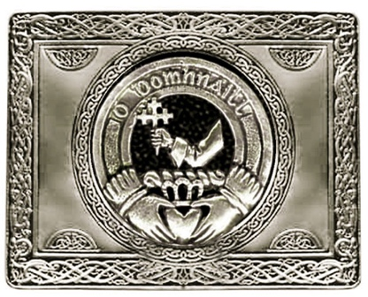

Click picture to buy/visit site

***Glengarry (Hat):*** “Black Watch Ancient” Tartan – Tartan Glengarries

$45

Tartan Glengarries “Black Watch Ancient”

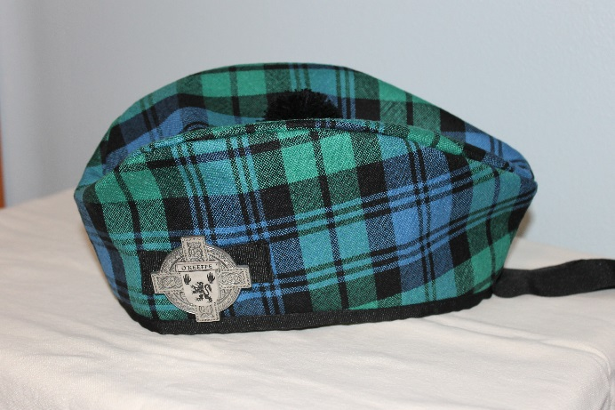

Click picture to buy/visit site

***Cap Badge (Brooch):*** Sterling silver or pewter “Celtic Cross” style

***- Members may add their military service insignia or clan crest***

***-No odd shapes***

**Example #1 Example #2**

$$ - Prices vary $25

Pewter or Silver Irish Coat of Arms/Celtic Cross Irish Family Crest Cap Badge/Brooch

Cap Badge (Family Name) Choose "Harp" or (Family Name)

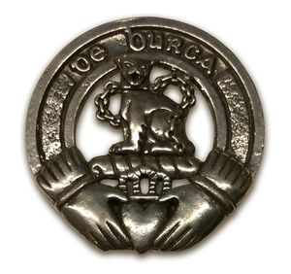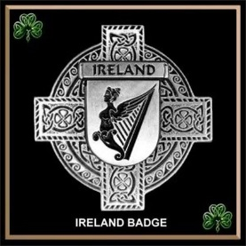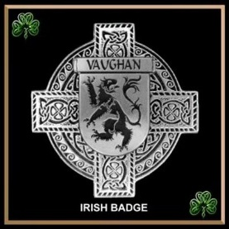

Example (This style is authorized if you can find it) Click picture to buy/visit site

**More Examples**

$25 $35 $25

Click picture to buy/visit site Click picture to buy/visit site Click picture to buy/visit site

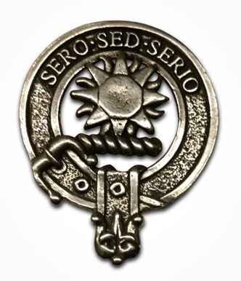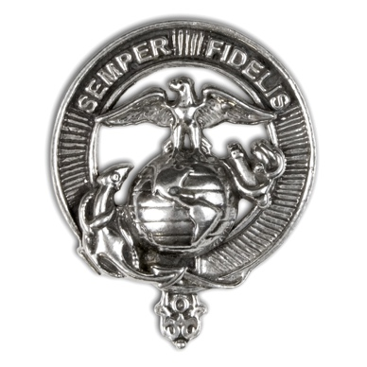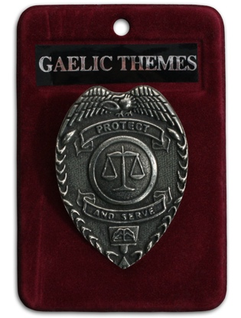

Clan Crest Cap Badge US Marine Corps LE Cap Badge

Pewter Cap Badge

***Kilt Hose (Socks):*** Economy Wool Blend Kilt Hose (Black)

$15

Economy Wool Blend Kilt Hose “Black”

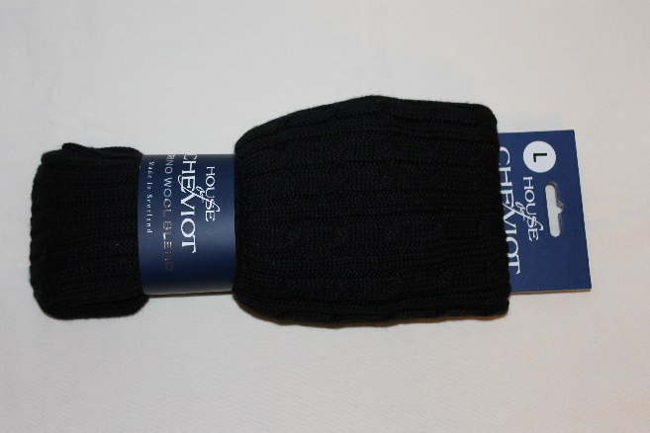

Click picture to buy/visit site

***Flashes (Worn over Kilt Hose):*** Wool Flash (Ancient Blue)

$25

Wool Flashes “Ancient Blue”

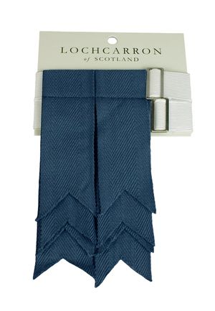

Click picture to buy/visit site

***Ghillie Brogues (Shoes):*** All black shoes with a high polish and “broguing”

***-No boots, no buckles***

**Example #1 Example #2**

$99 $149

Synthetic Sole Ghillie Brogues Light Weight Piper Ghillies

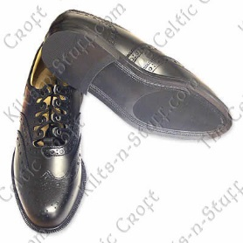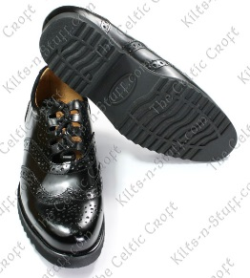

Click picture to buy/visit site Click picture to buy/visit site

***Kilt Pins:*** Sterling silver or pewter “sword” kilt pin with limited options:

***-Members may add their military service insignia or clan crest***

***-Color/material must sterling silver or pewter (not gold or brass)***

**Example #1 Example #2**

$25 $25

Irish Family Crest Kilt Pin Protect and serve Kilt pin

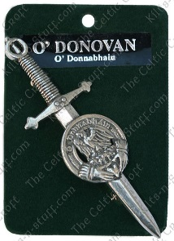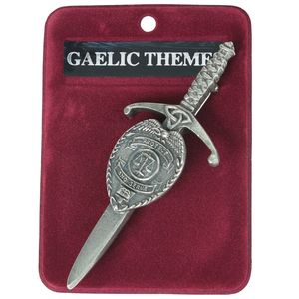

Click picture to buy/visit site Click picture to buy/visit site

**Uniform List by vendor source (In case hyperlinks change):**

**OPES Badge and Uniform Patches**

1. OPES Badge ($130+) - OPES Board Member

2. OPES Patches, x2 ($10) - OPES Board Member

**Uniform Shirt(s) [Galls or Quartermaster]**

1. Uniform Shirt ($19-23): Long sleeve, black uniform shirt (Like the LawPro Long Sleeve Uniform Shirt) - Any vendor / Like Galls, Quartermaster, etc.

2. Uniform Shirt ($18-23): Short sleeve, black uniform shirt (Like the LawPro Short Sleeve Uniform Shirt) - Any vendor / Like Galls, Quartermaster, etc.

**Uniform Kilt and Highland Gear [The Celtic Croft (www.kilts-n-stuff.com)]**

1. Kilt

A. ($299) Poly Viscose Medium Weight Casual Kilt - The Celtic Croft (www.kilts-n-stuff.com); or

B. ($109) Black Watch Economy Kilt - The Celtic Croft (www.kilts-n-stuff.com)

2. Leather Kilt Belt ($25-49) (Like the Quality Embossed Leather Kilt Belt or Economy Pebble Grain Leather Kilt Belt) - Any vendor / The Celtic Croft (www.kilts-n- stuff.com)

3. Kilt belt buckle ($25) (Like Antiqued Celtic Cross Kilt Belt Buckle) - Any vendor / The Celtic Croft (www.kilts-n-stuff.com)

4. Tartan Glengarry (Cap) ($45), "Black Watch Ancient" - The Celtic Croft (www.kilts-n-stuff.com)

5. Cap Badge/Brooch ($25) (Like the Irish Family Crest Cap Badge or the Pewter or Silver Irish Coat of Arms - Any vendor / The Celtic Croft (www.kilts-n-stuff.com)

6. Kilt Hose (Kilt socks) ($15) black (Like the Wool Blend Kilt Hose - Black) - Any vendor / The Celtic Croft (www.kilts-n-stuff.com)

7. Flash, Wool ($25) - Ancient Blue - Any vendor (but may be called Royal Blue) / use "Ancient Blue" at The Celtic Croft (www.kilts-n-stuff.com)

8. Ghillie Brogues (shoes) ($99-149), black (Must have broguing, no buckles) - Any vendor / The Celtic Croft (www.kilts-n-stuff.com)

9. Kilt pin ($25) (Silver or pewter, Irish or Family name) - Any vendor / The Celtic Croft (www.kilts-n-stuff.com)

**Sporran [L&M Highland Outfitters - Contact Tammy]**

1. Sporran ($190) - Custom made for "Oregon Police Emerald Society" by L&M Highland Outfitters, contact: Tammy Jennex at sales@landmhighland.com